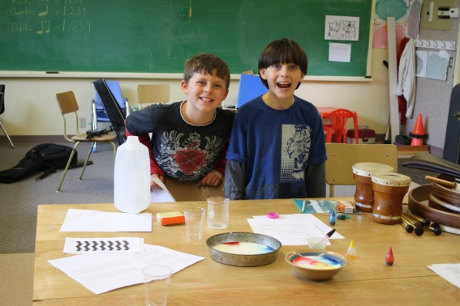
Science Fair

Jacob and Carson had a mini science fair this week conducting numerous experiments on “Light”. They presented two of their favourite experiments to Emerson and Liam.
May 16-19: Monday to Thursday
May 24-27: Tuesday to Friday

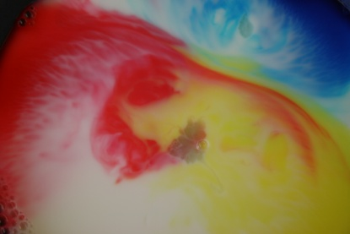
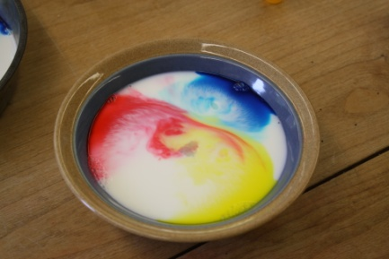
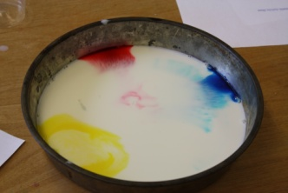
Fun with SEEC

We enjoyed an afternoon this week up at the SEEC site with the Pender Spring Leaves (home schoolers) and some of the SEEC students from Salt Spring who led us through interesting outdoor activities.

“Captain” and his trainer gave a fascinating demonstration searching for lost people (Jacob and Carson).

We led the group in fun sing along.
Upcoming Events...

May 18th PAC Meeting

May 19th Interview for Saturna Elementary School Vice - Principal to be held on Saturna at the school.

May 28th PAC Bottle Drive

June 2nd Sports Day on Galiano

June 9th Bike Rodeo on Mayne Island

June 13th Field Trip to East Point – “Seals” by Athena

June 14th Field Trip to Victoria – Island View Beach CRD program on crabs and other sea life.

August 15th to 19th - GICEL on Saturna

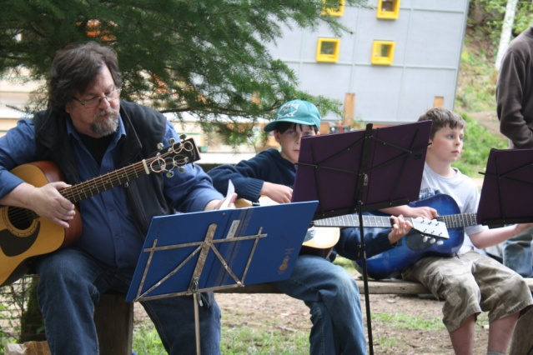

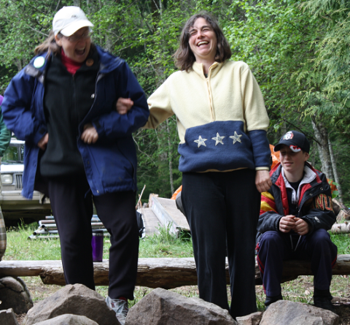

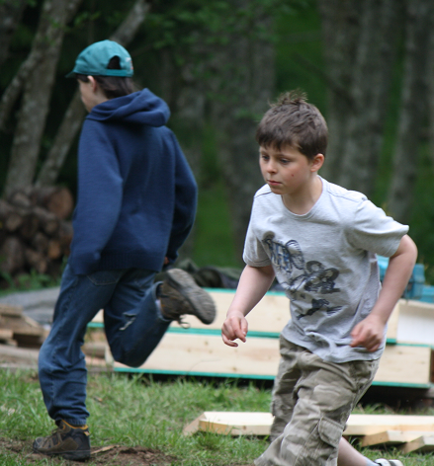
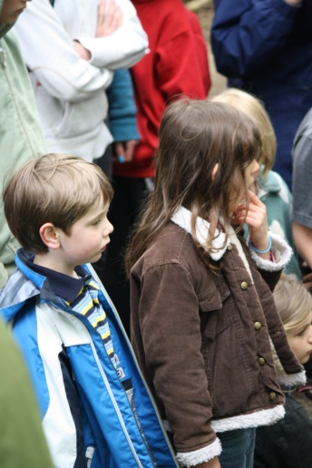

Plantings
We have quite a collection of plants growing in our classroom. Emerson and Liam have conducted experiments to discover what plants need to grow.

